FOR IMMEDIATE RELEASE
SEPTEMBER 21, 2013

FOR MORE INFORMATION CONTACT:
Kim Jackson, Harris County Flood Control District Communications
713-582-5124
kimberlye.jackson@hcfcd.org

SAN FELIPE STREET BRIDGE CLOSURE DELAYED DUE TO WEATHER
Harris County Flood Control District expects to start construction of bridge inside Loop 610 on Sept. 23

HOUSTON – Due to weather delays, the Harris County Flood Control District has postponed the scheduled Sept. 22 closure of the San Felipe Street bridge located at the railroad tracks just east of Mid Lane inside West Loop 610 in the Galleria area. Construction is now scheduled to start on Monday, Sept. 23 after the evening rush hour, weather permitting, and the 50-year-old bridge will be closed to all traffic for up to two weeks while it is demolished and replaced.

Crews will be working extended hours to expedite completion and minimize inconvenience. Please note: Road closures and construction schedules are subject to change. The Flood Control District will notify the public if there are additional modifications to this schedule.

If their ultimate destination is not in the area, motorists are encouraged to avoid the area while the bridge is under construction and to use an alternate route. Possible alternate routes include West Loop 610, Memorial Drive, Westheimer Road, Richmond Avenue or Kirby Drive. Signs announcing the street closure dates will be installed in the area prior to the closure. Motorists are encouraged to be alert, to pay attention to all posted street and lane closures and to take an alternate route. The San Felipe bridge closure schedule is subject to change due to construction or weather issues.

The San Felipe bridge replacement is part of the Flood Control District’s $13.2 million W129-00-00 Channel Enclosure Project, which is rebuilding and enclosing the poorly functioning drainage channel formally identified as HCFCD Unit W129-00-00. The work spans the section of W129-00-00 from San Felipe to Richmond and includes enclosing the drainage channel with dual 12-foot by 10-foot reinforced concrete box culverts and replacing the bridges at Westheimer and San Felipe. The Westheimer bridge replacement was completed in April 2013. The City of Houston is contributing funds to the bridge projects.

The Flood Control District is committed to communicating information about the project to affected individuals and organizations so that citizens can make informed decisions to minimize inconvenience during construction. In addition to installing signage detailing alternate routes in the area, District officials have met with local homeowners’ and civic associations, churches, schools, businesses and transportation and emergency services providers to provide information about the project and to answer questions.

For more information on the W129-00-00 project or the opportunity to sign up to receive e-mail updates, please visit the W129-00-00 project webpage at www.hcfcd.org/W129 or call the Flood Control District’s Project and Study Information Line, which is monitored daily, at 713-684-4040.

ABOUT THE W129-00-00 DRAINAGE CHANNEL
The W129-00-00 drainage channel flows northward from Westpark Drive inside West Loop 610 and runs parallel to the Union Pacific Railroad tracks. It drains into Buffalo Bayou on the southern edge of the City of Houston’s Memorial Park. Along its approximately 2-mile route, W129-00-00 crosses under U.S. 59, Richmond, Westheimer and San Felipe, all of which carry heavy loads of traffic between the Galleria area and downtown Houston. The drainage channel is bordered by concentrated areas of residential and commercial development.

The Flood Control District has been maintaining the drainage channel since the mid-1950s. The drainage channel has exceeded its design life, and over time the slopes of W129-00-00 have experienced concrete failures and erosion. The easement for the drainage channel is restricted to a narrow 35-foot area, and that property is owned by Union Pacific Railroad and CenterPoint Energy.

The Flood Control District recognized the need for repairs and launched a three-phase reconstruction project in 2004.
The first phase of the project consisted of replacing eroded sections of W129-00-00 between San Felipe and Buffalo Bayou. This $9.4 million project added depth and capacity to the drainage channel by enclosing it in dual 12-foot by 10-foot reinforced concrete box culverts. That phase of the project was completed in 2006.

The second and current phase began in August 2011 and focuses on the section of the drainage channel from San Felipe to Richmond. The third phase, which has not yet been designed or funded for construction, will span from Richmond to Westpark.

ABOUT THE HARRIS COUNTY FLOOD CONTROL DISTRICT
The Harris County Flood Control District provides projects that reduce flooding risks and damages from bayous and creeks, with appropriate regard for community and natural values. With more than 1,500 bayous and creeks totaling approximately 2,500 miles in length, the Flood Control District accomplishes its mission by devising flood damage reduction plans, implementing the plans and maintaining the infrastructure. To learn more about the Flood Control District, visit www.hcfcd.org.

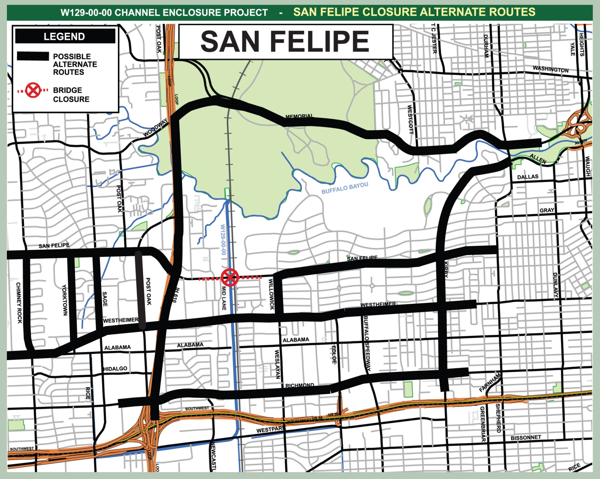

Alternate Routes for San Felipe Bridge Closure
On Sept. 23, after the evening rush hour, the Harris County Flood Control District will close the San Felipe Street bridge located just east of Mid Lane inside West Loop 610 in the Galleria area. The bridge will be closed to all traffic for up to two weeks while the 50-year-old bridge is demolished and replaced. Possible alternate routes include West Loop 610, Memorial Drive, Westheimer Road, Richmond Avenue or Kirby Drive.

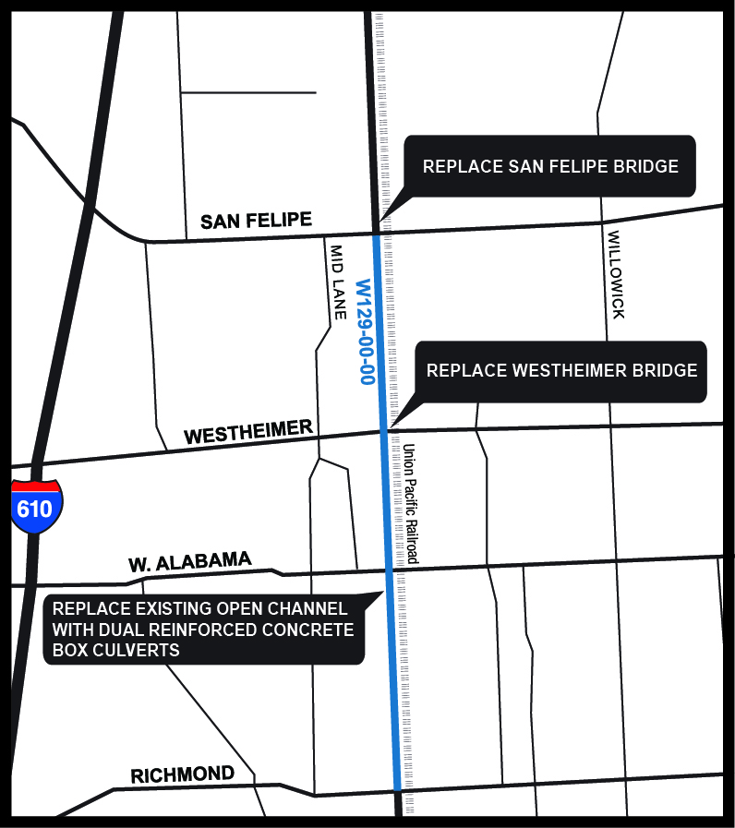

W129-00-00 Channel Enclosure Project Area Map
In August 2011, the Harris County Flood Control District began the W129-00-00 Channel Enclosure Project on the Galleria area drainage channel formally identified as HCFCD Unit W129-00-00. The project spans W129-00-00 from San Felipe Street to Richmond Avenue and includes enclosing the drainage channel with dual 12-foot by 10-foot reinforced concrete box culverts and replacing the bridges at Westheimer and San Felipe. The Westheimer bridge replacement was completed in April 2013, while work on the San Felipe bridge is expected to begin on September 23, 2013, after the evening rush hour.

